Infosys Springboard Virtual Internship 6.0 Completion Report

Team Details:

Batch Number: 6 Neurofleetx
Start date : 10-Nov-2025
Name: SUBASHINI K
Internship Duration: 8 Weeks

Project Title
SmartDeliveryRoute(TrackMIle System)

2. Project Objective
The SmartDeliveryRoute system includes a modern and responsive frontend interface designed to provide clear visibility and smooth interaction for both Admins and Delivery Personnel. The primary objective of the frontend is to present real-time delivery data in a user-friendly and interactive manner, bridging the gap between users and the backend system.
- Real-Time Visibility:
The frontend displays live driver locations on an interactive map by continuously fetching GPS data from the backend, allowing Admins to monitor deliveries in real time.
- Role-Based Dashboards:
Separate dashboards are provided for Admins and Delivery Personnel, ensuring that each user accesses only the features relevant to their role.
- Efficient User Interaction:
The frontend simplifies order creation, delivery tracking, and status updates through intuitive forms, tables, and visual indicators.
- Seamless Integration:
Built using React.js, the frontend integrates smoothly with the Spring Boot backend APIs to ensure fast data updates and a responsive user experience

3. Project description in detail

SmartDeliveryRoute (TrackMile) is a comprehensive web application that connects fleet managers (Admins) and delivery personnel (Drivers) through an intuitive and responsive frontend interface.
As the Frontend Developer, my role focused on designing and developing the visual layer and user interaction logic of the system using React.js.
The frontend follows a component-based architecture, where each screen is divided into reusable and manageable components. It communicates with the backend through secure REST APIs to fetch and update real-time delivery data.
- Component-Based Design:
I developed reusable React components such as Login, Navbar, Dashboard Cards, Forms, Tables, and Map Views. This modular approach improves code reusability, readability, and maintainability.
- Role-Based Navigation:
The frontend implements role-based routing to ensure that Admins are redirected to the Admin Dashboard and Delivery Personnel are redirected to the Delivery Dashboard after login.
- Real-Time Tracking Interface:
A major feature of the frontend is the live tracking view. The Admin dashboard periodically fetches updated driver location data from the backend and renders real-time movement on the map without page refresh.
- Dynamic Data Rendering:
React state and lifecycle management are used to dynamically update order status, delivery progress, and dashboard metrics such as active orders and completed deliveries.
- User Experience & Responsiveness:
The UI is designed to be clean, simple, and responsive, ensuring ease of use for both desktop and mobile users. Visual indicators such as status badges and action buttons enhance clarity during live operations.
- Frontend Security Handling:
The frontend handles authentication tokens securely and restricts access to protected routes, ensuring unauthorized users cannot access dashboards.
Ultimately, the frontend transforms complex backend data into a clear, real-time, and interactive user experience, enabling efficient delivery monitoring, faster decision-making, and smooth coordination between Admins and Drivers.
4. Timeline Overview
Week | Activities Planned | Activities Completed
Week 1 | Requirement gathering and frontend architecture planning. | Analyzed project requirements; finalized frontend scope for Admin and Delivery dashboards; selected ReactJS as the frontend framework.
Week 2 | Frontend project setup and UI structure design. | Created React project structure; designed folder architecture for components, pages, and services
Week 3 | Login and role-based authentication UI development. | Developed Login and Register pages; implemented role-based routing for Admin and Delivery users.
Week 4 | Admin Dashboard UI development. | Designed Admin Dashboard layout including summary cards, order creation form, and active deliveries table..
Week 5 | Delivery Dashboard UI development. | Built Delivery Dashboard with assigned orders view, route display, and delivery status update options.
Week 6 | Real-time tracking UI and map integration. | Integrated live map view; implemented polling mechanism on frontend to fetch real-time driver location updates.
Week 7 | Frontend–Backend integration and testing. | Connected React frontend with Spring Boot APIs; tested data flow for orders, tracking, and authentication
Week 8 | Final UI refinement, debugging, and documentation.. | Fixed UI bugs and routing issues; improved responsiveness; finalized frontend documentation and screenshots.

5a. Key Milestones
Milestone | Description | Date Achieved
Frontend Project Kickoff | Defined frontend objectives and finalized ReactJS component-based architecture for Admin and Delivery dashboards. | 17-Nov-2025
UI & Component Design | Designed reusable React components including Login, Navbar, Dashboard cards, forms, and tables.. | 29-Nov-2025
Authentication & Routing | Implemented login UI and role-based routing for Admin and Delivery users. | 14-Dec-2025
Admin Dashboard Development | Completed Admin Dashboard UI with order creation, live status cards, and active deliveries view. | 29-Dec-2025
Frontend Final Submission | Submitted complete frontend code, documentation, and integrated demo with backend services. | 2-Jan-2026

5b. Project execution details

Requirement Analysis:
Identified the need for a user-friendly and real-time frontend interface to display live delivery tracking and simplify interactions for Admins and Delivery Personnel.
• Technology Selection:
Chose ReactJS for its component-based architecture, fast rendering, and ability to handle frequent real-time updates efficiently.
• System Design:
Designed the frontend using a component-based structure, separating pages, reusable UI components, and API service logic for better maintainability.
• Frontend Development:
Developed responsive user interfaces for Login, Admin Dashboard, and Delivery Dashboard, including forms, tables, dashboard cards, and navigation components.
• Real-Time Data Handling:
Implemented periodic data fetching to display live driver locations, delivery status updates, and dashboard metrics without page reload.
• Data Rendering & Filtering:
Used React state management to dynamically filter and display relevant data, such as active deliveries and completed orders.
• Testing:
Performed thorough frontend testing by validating UI behavior, API integration, role-based routing, and real-time data updates using browser developer tools and test data.

6. Snapshots / Screenshots

Step 1: Frontend Initialization

Starting the ReactJS Development Server:
This screenshot shows the successful launch of the React frontend application using the development server, confirming that the project setup is complete.
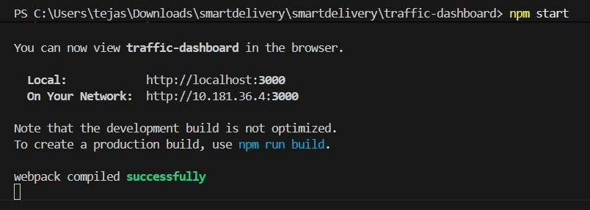

Step 2: Login Page
This screen allows Admin and Driver to log in using their credentials.
Based on the selected role, users are redirected to the appropriate dashboard.

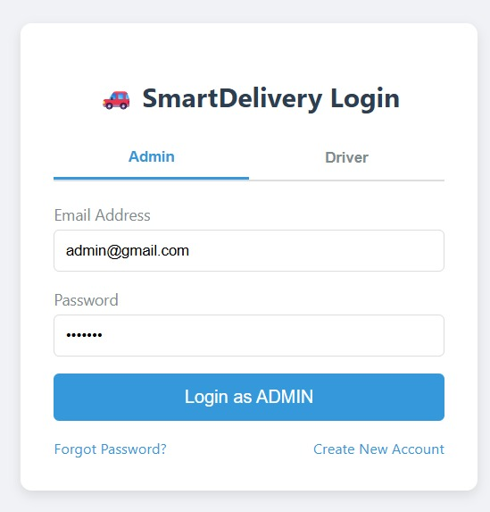

Step 3: Admin Dashboard
The Admin Dashboard displays live summary cards showing drivers, orders, and deliveries.
All data is updated dynamically using ReactJS without page refresh.
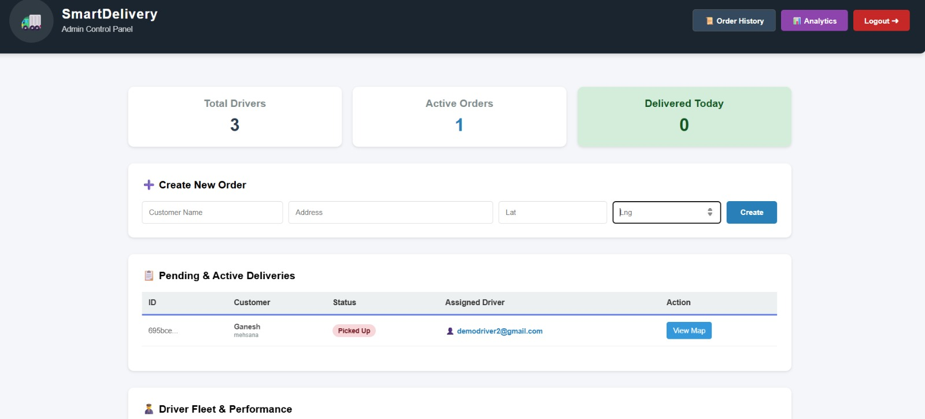

Step 4: Active Deliveries Table
This table shows ongoing deliveries with status and assigned driver details.
The “View Map” option enables real-time tracking.
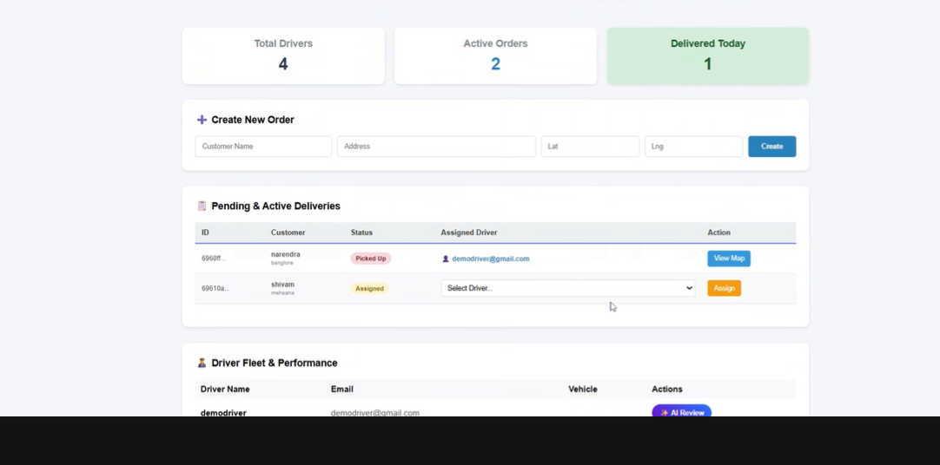

Step 5: Live Tracking Map
The map displays the driver’s live location and delivery route.
Location updates are refreshed automaticall y in real time.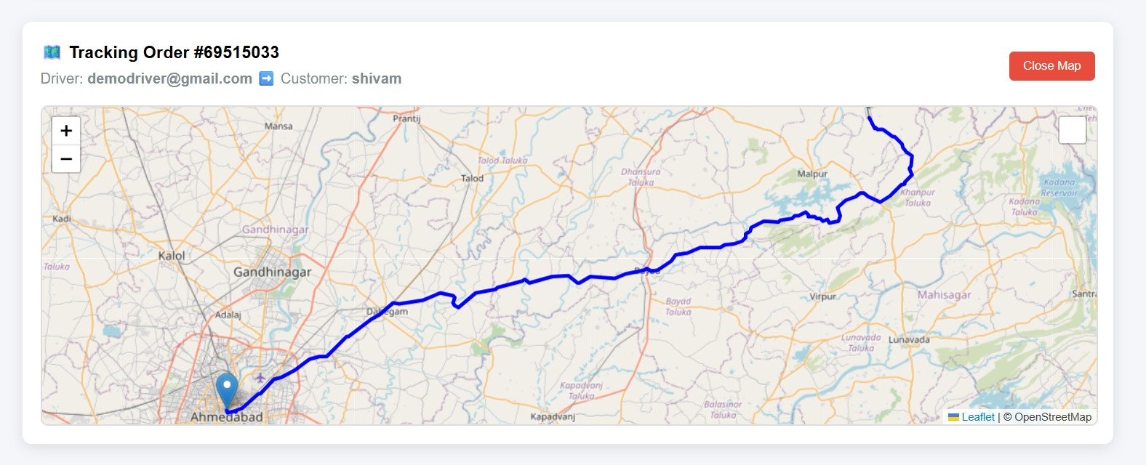

7. Challenges Faced
• Real-Time UI Updates
Ensuring smooth map and status updates with frequent location data was challenging. This was addressed by implementing optimized data polling and efficient state updates in React.
• State Management Complexity:
Managing live data across multiple components required careful state handling to avoid unnecessary re-renders.
• Role-Based Routing Issues:
Restricting access to dashboards based on user roles was initially complex and resolved by implementing protected routes.
• Frontend–Backend Integration Issues:
CORS and API response handling issues were resolved by proper configuration and consistent data formatting.

8. Learnings & Skills Acquired
ReactJS Architecture:
Gained strong experience in building scalable frontend applications using component-based architecture.
• State & Lifecycle Management:
Learned to manage real-time data updates efficiently using React state and lifecycle methods.
• API Integration:
Developed skills in integrating frontend applications with backend REST APIs.
• UI/UX Design:
Improved ability to design clean, responsive, and user-friendly dashboards.
• Real-Time Visualization:
Understood how to render live location tracking and dynamic data updates in frontend applications.

9. Testimonials from Team
Backend Developer:
“Subashini’s frontend dashboards were clean, responsive, and well-structured. Her React component-based approach made it easy to integrate backend APIs and ensured smooth real-time data updates across the application.”
Team Member:
Subashini played a key role in developing the Admin and Delivery dashboards. Her work on real-time tracking UI and role-based navigation improved the overall usability of the system.”

10. Conclusion
The SmartDeliveryRoute frontend has been successfully developed to provide a responsive, real-time, and user-friendly interface for both Admins and Delivery Personnel. Using ReactJS, the frontend effectively transforms backend data into meaningful visual insights, enabling efficient monitoring and smoother delivery operations.

11. Acknowledgements
I would like to sincerely thank Infosys Springboard for providing this opportunity to work on the SmartDeliveryRoute project. I am grateful to my mentor for guidance on frontend architecture and ReactJS best practices. I also thank my teammates for their support and collaboration in integrating the frontend with backend and AI components.

